November 11, 2015  at  Cobb Galleria Centre | 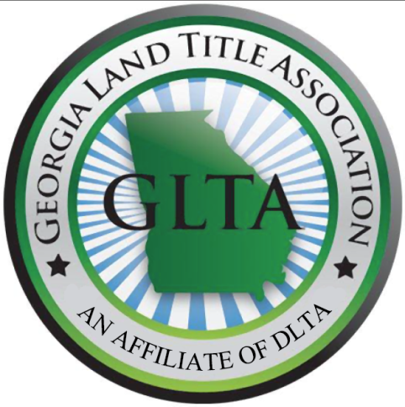 | SPECIAL THANKS  TO OUR SPONSORS:  Simplifile  SoftPro  ReQuire

The Education Committee of the
Georgia Land Title Association, LLC
Presents:

FALL 2015 SEMINAR
6.0 Hours of CLE Credit including 1 Hour of Ethics(GA)
AL DO ICE Credits pending approval
Plus a Fantastic Lunch

NOT TO BE MISSED! SEATING LIMITED!

Register ONLINE for Seminar/CLE with Buffet Lunch included

REGISTER ONLINE at www.DLTA.net

Please bring a jacket or sweater as the room may be cooler in the morning.

Seminar and Lunch

DLTA MEMBERS $120.00*– ADD $30.00 FOR CLE CREDIT

NON-DLTA MEMBERS $170.00* – ADD $30.00 FOR CLE CREDIT

IF SENDING A CHECK: DIXIE LAND TITLE ASSOCIATION, INC.
Linda Alwood, Executive Director
Dixie Land Title Association
P.O. Box 14806
Baton Rouge, LA 70898

QUESTIONS? CALL OR E-MAIL: Amanda Calloway
Phone 678-406-8918 Email amandac@titlelaw.com
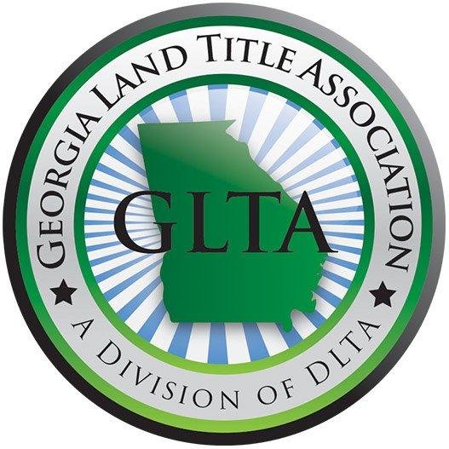

FALL 2015 AGENDA November 11, 2015

8:15 Registration Opens

8:50 Welcome Remarks: Amanda Calloway, Esq.
Education Committee Chairperson

9:00-10:00 Economic Forecast
KC Conway
SunTrust Bank

10:00-10:50 SURVEYS
Kyle Levstek, Esq.
Calloway Title and Escrow, LLC

10:50 15 Minute Break

11:05-12:35 Underwriting Panel
Tim Raffa- Old Republic
Gray Olive- Investors Title
Tamara Brooks- Chicago Title
Leonard Gray- First American Title.
Polly Campbell- Fidelity National Title
Patrick Hagler- Stewart Title

12:35 Lunch

1:35-2:25 LURAs and LURKs
Tom Kurrie, Esq.
Mary Margaret Williams, Esq.
Coleman Talley LLP
2:25 15 Minute Break

2:40-3:40 Ethics
Monica K. Gilroy, Esq
Gilroy Bailey Trumble LLC

3:40-4:30 Planned Developments: Lessons Learned – Avoiding the 5 Major Mistakes Made by Lawyers and Developers in a Growth Cycle
Jeffrey H. Schneider, Esq.
Weissman Nowack Curry & Wilco, P.C.

REGISTRATION FOR GEORGIA TITLE SCHOOL
NOVEMBER 11, 2015 AT THE COBB GALLERIA CENTRE
First Name:____________________________________

Middle Initial:__________________________________

Last Name:____________________________________

Company:_____________________________________

Bar Number:___________________________________

Address:_________________________________
_________________________________
_________________________________

Email:________________________________________
Phone:_______________________________________
GLTA is going GREEN. Materials will be emailed to all attendees several days before the seminar. Hard Copies will also be available on the day of the seminar

REGISTER ONLINE AT WWW.DLTA.NET OR BY MAIL
Amount of Check Enclosed:
____ $120 (DLTA member, no CLE credit)
____ $150 (DLTA member, include CLE credit)
____$170 (Non-DLTA member, no CLE credit)
____$200 (Non-DLTA member, include CLE credit)
Please mail check and registration to: DIXIE LAND TITLE ASSOCIATION, INC.
Linda Alwood, Executive Director
Dixie Land Title Association
P.O. Box 14806
Baton Rouge, LA 70898

