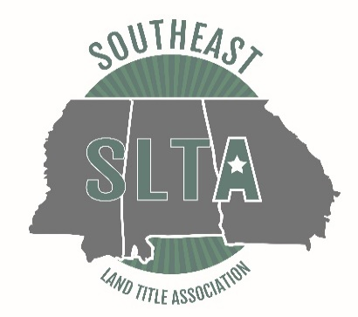

7:45 Registration Opens

8:05-8:15 Welcome Remarks- Amanda Calloway, Esq., Education Chairperson GLTA

8:15-9:15 Title Examination & Review
Joanne V. Capeloto, Attorney

9:15-10:15 “All You Wanted to Know About Surveying but Were Afraid to Ask,” or “Is That a Rod (Perch or Pole), or Are You Just Happy to See Me?”
Moderator: Kyle J. Levstek, Esq.
Calloway Title and Escrow, LLC
Panel Members:
Mark Chastain
Chastain & Associates, P.C.
Virgil T. Hammond
Watts & Browning Engineers

10:15-10:30 15 Minute Break

10:30-11:30 Update and Hot Topics from the ALTA Convention
Monica K. Gilroy, Esq.
Gilroy Bailey Trumble LLC
Deborah S. Bailey, Esq.
Gilroy Bailey Trumble LLC

11:30 Lunch

12:15-1:15 Thing Rarely go Perfectly in Marriage or in Closings…Keep Your Tylenol Handy!
Alera “Jill” Elliott, Esq.
Jill Elliot, LLC

1:15-1:30 15 Minute Break

1:30-2:15 Closing Check List to Avoid Title Claims
Rhee E. McCallum, Associate Underwriter
Chicago Title Insurance Company

2:15-3:30 SOLVED (Satisfaction Of Liens Via Electronic Database) – House Bill 337
Introduction: Tim Minors, Esq., Vice President and Georgia State Counsel
Old Republic National Title Insurance Company
Speaker: Scott Purvis, Director
Compliance Division, Georgia Department of Revenue

