October 9, 2014  at  Cobb Galleria Centre | 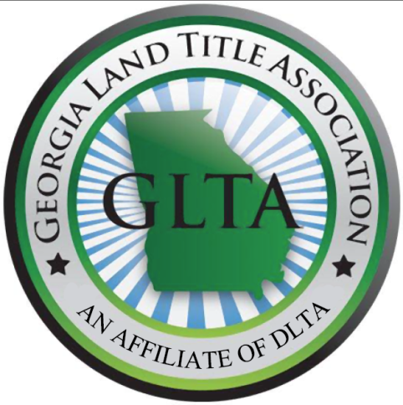 | SPECIAL THANKS  TO OUR SPONSORS:  Simplifile  SoftPro  ReQuire  Positively Balanced

The Education Committee of the
Georgia Land Title Association, LLC
Presents:

FALL 2014 SEMINAR
6.0 Hours of CLE Credit including 1 Hour of Ethics
Plus a Fantastic Lunch

NOT TO BE MISSED! SEATING LIMITED!

Register ONLINE for Seminar/CLE with Buffet Lunch included

REGISTER ONLINE at www.DLTA.net

Please bring a jacket or sweater as the room may be cooler in the morning.

Seminar and Lunch

DLTA MEMBERS $120.00*– ADD $30.00 FOR CLE CREDIT

NON-DLTA MEMBERS $170.00* – ADD $30.00 FOR CLE CREDIT

*$25 additional fee for walk-up registration
*While we appreciate changes in your schedules, we must confirm the number of participants, there will be no refunds after October 1, 2014. You may substitute someone from your firm or company.

IF SENDING A CHECK: DIXIE LAND TITLE ASSOCIATION, INC.
Linda Alwood, Executive Director
Dixie Land Title Association
P.O. Box 14806
Baton Rouge, LA 70898

QUESTIONS? CALL OR E-MAIL: Amanda Calloway
Phone 678-406-8918 Email amandac@titlelaw.com
REGISTRATION FOR GEORGIA TITLE SCHOOL
OCTOBER 9, 2014 AT THE COBB GALLERIA CENTRE
First Name:____________________________________

Middle Initial:__________________________________

Last Name:____________________________________

Company:_____________________________________

Bar Number:___________________________________

Address:_________________________________
_________________________________
_________________________________

Email:________________________________________
Phone:_______________________________________

GLTA is going GREEN. Materials will be emailed to all attendees several days before the seminar. Hard Copies will also be available on the day of the seminar.

Amount of Check Enclosed:
____ $120 (DLTA member, no CLE credit)
____ $150 (DLTA member, include CLE credit)
____$170 (Non-DLTA member, no CLE credit)
____$200 (Non-DLTA member, include CLE credit)
Please mail check and registration to: DIXIE LAND TITLE ASSOCIATION, INC.
Linda Alwood, Executive Director
Dixie Land Title Association
P.O. Box 14806
Baton Rouge, LA 70898

